

Casa de Gobierno
Paseo de la República 1500 Col. Oviedo Mota
Morelia, México
26-28 June 2003

SEMINAR PROCEEDINGS (Excerpt)

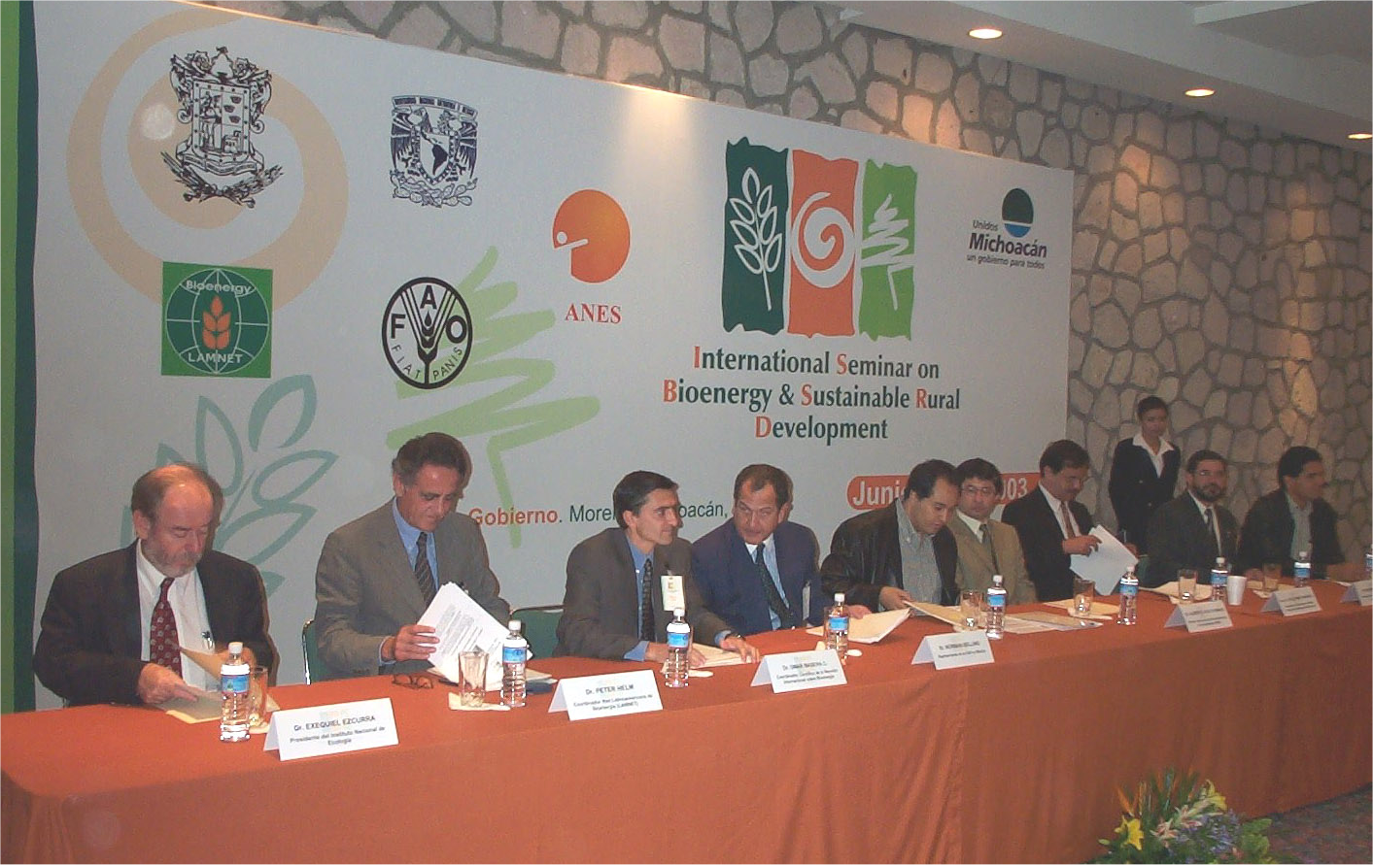






The International Seminar of Bioenergy and Sustainable Rural Development was held in Morelia, Mexico, from June 26 to 28 2003. It was organized jointly by the Latin American Thematic Network on Bioenergy (LAMNET), the Center for Ecosystem Research (CIECO) from the National Autonomous University of Mexico, the Food and Agriculture Organization of the United Nations (FAO), the National Association for Solar Energy (ANES) and the State Government of Michoacan, Mexico.
LAMNET - Latin America Thematic Network on Bioenergy
Coordination: WIP, Germany
Coordinator/ focal contact point:
Dr. Rainer Janssen (rainer.janssen@wip-munich.de)

Updated information on this workshop is available at http://www.bioenergy-lamnet.org, http://bioenergia.oikos.unam.mx and http://www.anes.org.

Workshop Organisation Support
Lic. Claudia Sánchez, Center for Ecosystem Research (CIECO), UNAM, México
M.S. Laura Hernández, Center for Ecosystem Research (CIECO), UNAM, México
Biol. Alan S. Cervantes, Center for Ecosystem Research (CIECO), UNAM, México
Biol. Adrián Ghilardi, Center for Ecosystem Research (CIECO), UNAM, México
Rodolfo Díaz, Center for Ecosystem Research (CIECO), UNAM, México
Dr. Javier Aguillón, Instituto de Ingeniería, UNAM, México
M. Arq. Ana Rosa Velasco, National Association for Solar Energy (ANES), México
Ing. Francesco Cariello, ETA-Florence, Italy
Dr. Giuliano Grassi, European Biomass Industry Association – EUBIA
Ing. Anton Hofer, WIP-Munich, Germany
Dr. Peter Helm, WIP-Munich, Germany

Editor of Workshop Proceedings
Dr. Rainer Janssen, WIP, Germany
Dr. Omar Masera, Center for Ecosystem Research (CIECO), UNAM, México
Dr. Eduardo Rincon, National Association for Solar Energy (ANES), México
Dr. Gustavo Best, Food and Agriculture Organization of the United Nations (FAO)

Published by: WIP-Munich

Sylvensteinstr. 2
81369 Munich, Germany
Phone: +49 89 720 127 35
Fax: +49 89 720 127 91
E-mail: wip@wip-munich.de

Web: www.wip-munich.de

WORKING GROUP 4: BIOMASS RESOURCES

International Seminar on Bioenergy and Sustainable Rural Development
- 5th LAMNET Project Workshop – Mexico 2003

A MULTISCALE ASSESSMENT OF WOODFUEL HOT SPOTS:
A CASE STUDY FOR MEXICO

Gabriela Guerrero, Adrián Ghilardi, Omar Masera
Centro de Investigaciones en Ecosistemas (CIECO), UNAM
AP 27-3 Xangari, 58089 Morelia, México
Email: gguerrer@oikos.unam.mx, aghilardi@oikos.unam.mx
Internet: http://bioenergia.oikos.unam.mx

1. INTRODUCTION

The large and widespread utilization of woodfuels in Mexico is associated to a host of environmental and socioeconomic impacts. Understanding national woodfuel use current patterns and trends will allow assessing these impacts, and help to achieve a sustainable use of this major energetic resource. However, the patterns of woodfuel production and consumption are rather complex and very site specific, complicating the development of a national perspective (Mahapatra & Mitchell, 1999; RWEDP, 1997 and 2000). National-level data are too aggregated to provide the sense of local variance, while local studies are too fragmented and discontinuous to convey the general picture.

Recognizing the site specificity of woodfuel use associated impacts should drive the thinking that there is a general fuelwood crisis to the assumption that critical areas vary from area to area. For example, regarding environmental impacts, even in regions with an overall negative woodfuel demand/supply balance, not all the places face woodfuel scarcity, and, similarly, regions with overall positive balance may include deficit areas with serious impact on natural resources (FAO, 1981; RWEDP, 1997 and 2000). Although the spatial variation in the patterns of woodfuel use and its associated impacts, current planning is still based on aggregate statistics at the national level that leads to inefficient policies and give poor guidance, or by the other side, on detail studies at the project level which presents severe problems for integrating the information at the national level (Masera et al, 1998).

Little is known, for example, about the amounts, extent, geographical location and dynamics of wood supplies: from plantation strategies, to traditional wood collection and harvesting methods. In these regards, one should realize that obtaining exact measures of woodfuel deficits (i.e., like the studies conducted using the traditional fuelwood gap model (De Montalambert & Clement, 1983; Newcombe, 1984)) presents severe methodological and financial challenges, particularly considering the scarce resources normally allocated to this specific sector (ESMAP, 2001). More feasible approaches are those oriented to identify problematic or potential areas within a country based on identifying woodfuels patterns and trends. In a second step, more in-depth analyses can be conducted, allowing a more efficient use of scarce available resources and better results.

There is an urgent need for spatial explicit approaches that help in strategic planning. The main feature of this kind of approaches must be their ability to follow hierarchical analysis through multiple spatial scales, from a national priorization, to the identification of those critical areas at a resolution consistent with the implementation of targeted policies. When recognizing key patterns of woodfuel use, spatial explicit multiscale approaches may facilitate the application of a set of tools directed to improve the sustainability of woodfuels use.

The Center for Ecosystems Research (CIECO) of the National University of Mexico (UNAM), in cooperation with the Food and Agriculture Organization of the United Nations (FAO), have developed the Woodfuel Integrated Supply/Demand Overview Mapping (WISDOM) (Masera et al, 2003a), a spatially explicit method for identifying woodfuel priority areas or “hot spots”. WISDOM is based on geographic information system (GIS) technology, which offers new possibilities for integrating statistical information about production and consumption of woodfuels. WISDOM attempts to integrate existing information and reduce the collection of costly new data.

In this articule we apply the WISDOM approach to Mexico. Subsequently we explore the possibility of identifying concrete areas for intervention at the project level, based on an accessibility analysis within the “Purhépecha Region” of Michoacan State.

2. The WISDOM APPROACH

The Woodfuel Integrated Supply/Demand Overview Mapping (WISDOM) is a spatial-explicit planning tool for highlighting and determining woodfuel priority areas or “woodfuel hot spots”. We recognize that woodfuels are connected to a set of interrelated socio-economic and environmental issues, and thus woodfuel hot spots can be defined in terms of its relevance for consumption patterns, production, and potential environmental impacts.

Woodfuel hot spots can be thus established according to a number of criteria set by the users. For example, in identifying areas with potential large social impacts, zoning can be done according to the number and density of woodfuel users and the scarcity of woodfuel resources. Studies looking at potential degradation caused by woodfuels use, will try to identify regions where woodfuel consumption is high, resilient, and increasing, where woodfuel supply is at risk, due to loss or degradation of natural vegetation, and where the demand-supply balance indicates a deficit or is likely to develop such condition in the near future.

WISDOM does not replace a detailed national biomass demand/supply balance analysis for operational planning but rather it is oriented to support a higher level of planning, i.e. strategic planning and policy formulation, through the integration and analysis of existing demand and supply related information and indicators. More than absolute and quantitative data, WISDOM is meant to provide relative/qualitative values such as risk zoning or criticality ranking, highlighting, at the highest possible spatial detail, the areas deserving urgent attention and, if needed, additional data collection. In other words, WISDOM should serve as an ASSESSING and STRATEGIC PLANNING tool to identify priority places for action.

WISDOM is based on:

- Geo-referenced data bases. A core feature of the approach is the spatial base on which the data is framed. The analysis and presentation of results for all modules is done with the help of a Geographic Information System (GIS).

- Minimum spatial unit of analysis at sub-national level. The spatial resolution is defined at the beginning of the study, on the basis of the wanted level of detail (national study, regional study) and as constrained by the main parameters or proxy variables that will be used to “spatialize” the information. In most cases the existing demographic data, such as census units, and land use/land cover data represent the main reference for the definition of the spatial base, which will be in all circumstances sub-national and preferably below state level.

- Modular and open structure. WISDOM consists of three basic modules: a demand module, a supply module, and an integration module. The first two modules require different competencies and data sources. Once the common spatial base of reporting is defined, each module is developed in total autonomy using existing information and analytical tools and is directed to the collection, harmonization, cross-referencing and geo-referencing of relevant information existing for the area of study.

- Adaptable framework. As mentioned before, the information of relevance to wood energy comes from multiple sources and is often fragmented and poorly documented, ranging from census data to local pilot studies or surveys, to projected estimates with unknown sources. Proxy variables may be used to “spatialize” discontinuous values. In synthesis, WISDOM tries to make all existing knowledge at work for a better understanding of woodfuel consumption and supply patterns.

The benefits of WISDOM include:
- Provides a consistent and holistic vision of the wood energy sector over the entire country or region and helps to determine priority areas for intervention.
- Constitutes an open framework and a flexible tool meant to adapt to existing information related to woodfuels demand and supply patterns.
- Allows the definition of critical data gaps resulting from the thorough review and harmonization of wood energy data.
- Promotes cooperation and synergies among stakeholders and institutions (Forestry, Agricultural, Energy, Rural development, etc.). In this, WISDOM will combat the fragmentation (of information, of responsibility) that so heavily limits the development of the sector.
- Allows to concentrate the actions on circumscribed targets and thus to optimize the use of available resources (human, institutional, financial, etc.).
- Enhances the political recognition of the real inter-sectoral role and priorities of the wood energy by policy makers.

The use of WISDOM involves five main steps (figure 1):

- Definition of the minimum administrative spatial unit of analysis:
The analysis should be carried out at the lowest administrative level for which demographic, social and economic parameters are available. In this step, spatial and statistical data are linked through a “map attribute table”, which has a database structure and contains the basic geographic attributes and identifiers of all individual elements of the digital map (identity codes and names, area, perimeter, coordinates, etc.). The table can be expanded as needed by the addition of thematic attributes referring to the same set of map elements.

- Development of the DEMAND module:
The main challenge of this module is to find either direct or proxy variables, available at the minimum subnational unit selected, that can be used to estimate consumption levels and their spatial distribution.
These variables should be disaggregated, if possible, by fuel type (fuelwood, charcoal, others), by sector of users (households, industrial, others) and by area (rural, urban), since each has a particular impact on sources and sustainability of supply, calling for separate lines of analysis.

- Development of the SUPPLY module:
This module provides a spatial representation of all woodfuel sources, their stocking capacity, their change over time, and their productivity. The main, and often the only, sources of information for developing this module are national forest inventories. A weak point of these data sources is that they do not differentiate woodfuels from other types of commercial or usable timber, overestimating the real woodfuel supply. Moreover, inferred data based on detailed surveys might be used regarding non forest land use classes, as forest inventories do not cover these areas. As mentioned earlier, the scope of WISDOM is not operational planning, for which quantitative precision is essential. Thus, with the scope of identifying priority areas where the demand-supply balance reveals a possible deficit, the supply module may concentrate mainly on land use and land use change, and may use indicative biomass productivity indices based on ecological characteristics.

- Development of the INTEGRATION module:
This module is used to integrate the information from the demand and supply modules. The integration is done through the combination of the variables related to woodfuel consumption and supply that have been systematized for each minimum administrative unit of analysis.

- Selection of the PRIORITY areas or “woodfuel hot spots”:
The last step of the methodology is the identification of those areas where action, or further investigation, is needed. This final objective may be achieved either by multivariate statistical procedures or by grouping some selected variables form the three modules into an overall index (Fuelwood Priority Index) which allows the priorization of each minimum administrative unit in terms of woodfuel demand, supply or both.

Figure 1. WISDOM Steps

3. MEXICO’S CURRENT PATTERN OF WOODFUEL USE

Biofuels represent 9% of total energy demand in Mexico. Fuelwood accounts for 37% of total residential energy use and more than 80% of the energy demand in the rural sector. Total fuelwood use accounts for three times the total commercial timber legally harvested in the country. Approximately 25 million people use fuelwood for cooking, boiling water or heating. Fuelwood is either collected or bought from local markets, and comes from commercial and non commercial forest areas, little from agricultural areas. Fuelwood demand is concentrated on rural areas and small towns. The patterns of fuelwood use are extremely diverse, with a high heterogeneity in terms of users and potential environmental impacts across the country (Masera et al, 1998; SENER, 2001).

4. WISDOM ANALYSIS FOR MEXICO

4.1 Assumptions and scope of the WISDOM analysis for Mexico.
When conducting the WISDOM analysis for Mexico, some prior assumptions were made taking into account the availability and reliability of data.

- Only forest areas were included in the analysis. The fuelwood supply coming from non-forest areas was not considered.
- Only fuelwood was considered in the analysis.
- Fuelwood production coming from forest areas was assumed to be equivalent to total biomass productivity by forest type This leads to an overestimation of the actual fuelwood supply.
- Only exclusive fuelwood users were taken into account. The INEGI census does not distinguish mixed fuel users (e.g. users of fuelwood and LP gas), although they represent a significant percentage of total fuelwood users (31% in 1990 (Díaz, 2000)). As there is no reliable direct estimate of this group of users as a separate sector, this study accounts only for the exclusive fuelwood users. Some underestimation in the fuelwood demand patterns should be expected.
- The analysis focused on the residential sector.

4.2 Step 1: Determining the minimum spatial unit of analysis.
The “municipio” (county: 2nd sub-national level) was selected as the minimum administrative unit of analysis for conducting WISDOM. A geo-referenced data base that covers the whole country and is articulated into the state and national level is available from the Mexican National Bureau of Statistics (INEGI). A total of 2,436 units were identified and incorporated into a GIS. For each unit, basic information such as: coordinates, area, and perimeter are available.

4.3 Step 2: Developing the demand module.
The INEGI census -currently available electronically at the “municipio” level - was used as the basic source of information for the module. The census includes general socio-demographic variables as well as variables related to the quality of living of the Mexican population. The average per capita fuelwood consumption by major ecological zone was estimated based on local surveys. Besides these two sources of information new variables were calculated for the completion of the demand module (Table 1).
Table 1. Variables used in the demand module
Original Variables from the National Census (1980/1990/2000) | - Population (urban, rural, total).  - Total number of households.  - Number of households that use exclusively fuelwood.  - Number of exclusive fuelwood users.  - Percentage of population belonging to an ethnic group.  - Socioeconomic index.
Original Parameters from Surveys | - Average per capita fuelwood consumption by major ecological zone (temperate, tropical dry, tropical humid, semi-arid and wetlands).
New variables calculated | - Saturation of fuelwood users (percentage of exclusive fuelwood household users).  - Annual fuelwood consumption (estimated as per capita fuelwood consumption times number of exclusive fuelwood users).  - Annual fuelwood consumption coming from forests (estimated as per capita fuelwood consumption coming from forest times number of exclusive fuelwood users)  - Average annual growth rate of exclusive fuelwood Users (1990-2000).  - Density of fuelwood users (exclusive fuelwood users per km², using the total municipality area).
Note: All these variables are disaggregated at the “municipio” level. In bold are the variables selected for the determination of “woodfuel hot spots”.

The annual fuelwood consumption coming from forest areas was estimated using a factor that varies by major ecological zone. This factor was estimated based on local studies (Del Amo, 2002; Masera et al, 1997; Masera et al, 1993). For tropical regions of México for example, about 20% of fuelwood consumption comes from non forest areas, which may include farmland trees, abandoned or regrowth areas due of shifting cultivation practices, and other places. In this case, the factor was set to 0.8. More detailed surveys covering all the ecological zones need to be conducted in order to obtain a more precise estimate of these proportions. The annual fuelwood consumption coming from forest is used at the integration module for calculating the fuelwood balance over forest areas.

4.4 Step 3: Developing the supply module.

To estimate the total woody biomass production from Mexican forests, average biomass productivities (in ton/ha/yr) for each of the major forest types was assumed and incorporated into the supply module. The distribution of the resulting biomass forest productivities within the country was calculated using a simplified vegetation map (7 classes), reclassified from the original National Forest Inventory vegetation map (69 classes) for the year 2000. A more detailed analysis of forest productivities, for example, using climate and soil conditions will be needed for a more accurate estimate of total biomass production at the “municipio” level. More over, conversion factors are needed to quantify the actual amount of fuelwood production as a fraction of the actual woody biomass productivity calculated. See Table 2.

Table 2. Variables used in the supply module
Original Variables from the National Forest Inventory (2000) | Area by each LU/LC class (ha).
Original Parameters from Surveys | Total aboveground biomass productivity by forest class (ton/ha/yr).
New variables calculated | Total forest area (ha) -includes temperate, tropical, shrubs, mangroves and other forests -.  Aboveground biomass production from forests (ton/yr).
Note: All these variables are disaggregated at the “municipio” level. In bold are the variables selected for the determination of “woodfuel hot spots”.

4.5 Step 4: Developing the integration module.
The information gathered in the supply and demand modules was combined to get a series of new variables -or indicators-. This procedure was done iteratively during the development of WISDOM, as some demand variables depend on variables from the supply module (e.g., per capita fuelwood use) and vice versa.

Two main integrated variables of interest at the “municipio” level derived were:
- Fuelwood Balance (forest biomass productivity - fuelwood demand coming from forests) in ton/yr.
- Pressure on Forest Resources (fuelwood demand coming from forests / total forest area) in ton/ha/yr.

4.6 Step 5: Identifying priority “municipios”.
The last step of the analysis was the determination of fuelwood “hot spots”. Four main sub-steps were necessary for achieving this task:

    - Selection of a robust set of variables associated to fuelwood consumption and supply by “municipio” to be used in setting priority municipalities:
Six uncorrelated or poorly correlated variables were selected from the original pool of ten variables: a) total number of exclusive fuelwood users: b) saturation of fuelwood users (proportion of households that use exclusively fuelwood); c) user density (number of exclusive fuelwood users / total municipality area); d) percentage of people belonging to an ethnic group; e) discrete annual growth rate of exclusive fuelwood users (1990-2000); f) fuelwood balance (total forest productivity - annual fuelwood consumption coming from forest areas).

4.6.2 Ranking of “municipios” in 5 groups in terms of each of the individual variables:
For each of the six variables selected, “municipios” were grouped and ranked into 5 categories, reflecting the acuteness -or priority- of the problem. The ranking was done by dividing each of the six selected variables in five intervals or “natural groups”. The objective of the priority ranking was to find municipalities that show: high fuelwood demand, high density and growth of fuelwood users; high resilience of fuelwood consumption (defined here as household’s attachment to fuelwood use for cooking due to social and cultural aspects); and few or insufficient woodfuel resources.

4.6.3 Construction of an integrated fuelwood priority index (FPI) by “municipio”:
Based on the priorization of each “municipio”, for each of the six variables selected, an overall fuelwood priority index was constructed as follows:

$${\text{FPI}}_{j}=\sum_{1}^{6}{I_{i}}∗P_{i}$$
where,

FPI_{j} = woodfuel priority index for each “municipio” “j”
Ii = index for each of the six variables used in the analysis -6 in total-, ranging from 1 to 5, according to the priority of the “municipio” in terms of the specific variable.
p_{j} = weights, set to 1 in our case.

4.6.4 Ranking of “municipios” in 5 groups according to the FPI:
With each “municipio” being assigned a numerical index that integrates the different concerns regarding fuelwood consumption and availability of resources, the final step was a regrouping into the five categories defined in the previous section: from low priority to high priority.

4.7 Results
Conducting a WISDOM analysis for Mexico allowed the categorization of 2402 “municipios” (out of 2436) in five groups according to their level of priority. The analysis showed that, from these 2402 “municipios”:

- 262 “municipios” à High priority
- 388 “municipios” à Mid-high priority
- 462 “municipios” à Medium priority
- 677 “municipios” à Mid-low priority
- 613 “municipios” à Low priority

A statistical analysis was conducted to corroborate the significance of these groups. An overall ANOVA confirmed that the five groups were statistically different at a 95% confidence level.

Table 3 shows the six variables used in the construction on the FPI index by group of ranked “muncipios”. It can be seen that high priority “municipios” show a high number of exclusive fuelwood users; a high percentage of houses that exclusively use fuelwood; a high density and growth of exclusive fuelwood users at the household level; a high resilience of fuelwood consumption (in terms of social and cultural aspects); and few or insufficient woodfuel resources from forests.
Table 3. Characteristics of each priority group of “municipios” according to selected variables.
FPI Groups | Number of Fuelwood exclusive users | Saturation of fuelwood users  (%) | User Density (A)  (users/ km2) | Indigenous population  (%) | Growth Rate of fuelwood users  (%) | Fuelwood Balance  (ton/yr)
High priority | 15,217  (987) | 86,1  (0.8) | 1.02  (0.04) | 68.2  (1.9) | 1.8  (0.2) | 20,816  (2112)
Mid-high priority | 11,628  (664) | 72,1  (1.2) | 0.61  (0.04) | 43.7  (1.9) | 1.2  (0.2) | 68,390  (13,733)
Medium priority | 9,765  (587) | 59,7  (1.3) | 0.38  (0.02) | 23.3  (1.4) | 0.0  (0.1) | 120,299  (18,343)
Mid-low priority | 5,880  (279) | 41,3  (1.1) | 0.22  (0.01) | 6.4  (0.6) | -1.4  (0.2) | 144,756  (15,555)
Low priority | 2,436  (118) | 17,8  (0.7) | 0.05  (0.00) | 0.8  (0.1) | -4.4  (0.2) | 543,977  (60,067)
Note: Standard error values are shown in brackets. Smallest “n” for any variable: 2401.

Figure 2 shows that the most critical states according to the percentage of their area covered by high priority “municipios” are Veracruz (60 “municipios”; 26,4% of its area); Puebla (53 “municipios”; 19,1% of its area); Hidalgo (14 “municipios”; 15,3% of its area); and Estado de Mexico (10 “municipios”; 14,9% of its area). The number of “municipios” ranked as “high priority” on the state of Oaxaca rises to 63, but they represent only 9,3% of the total area. This type of considerations should be made in order to categorize national priority areas for intervention or further investigation. Moreover to the inclusion of high priority “municipios” inside state boundaries, it is useful to recognize their distribution in aggregated areas, which may correspond to a continuum of site specific characteristics according to WISDOM modules parameters. The complete list of ranked “municipios” is posted as an annex in Masera et al (2003b).

Figure 2. Priority “municipios” in terms of fuelwood use and availability of fuelwood resources, Mexico 2000.
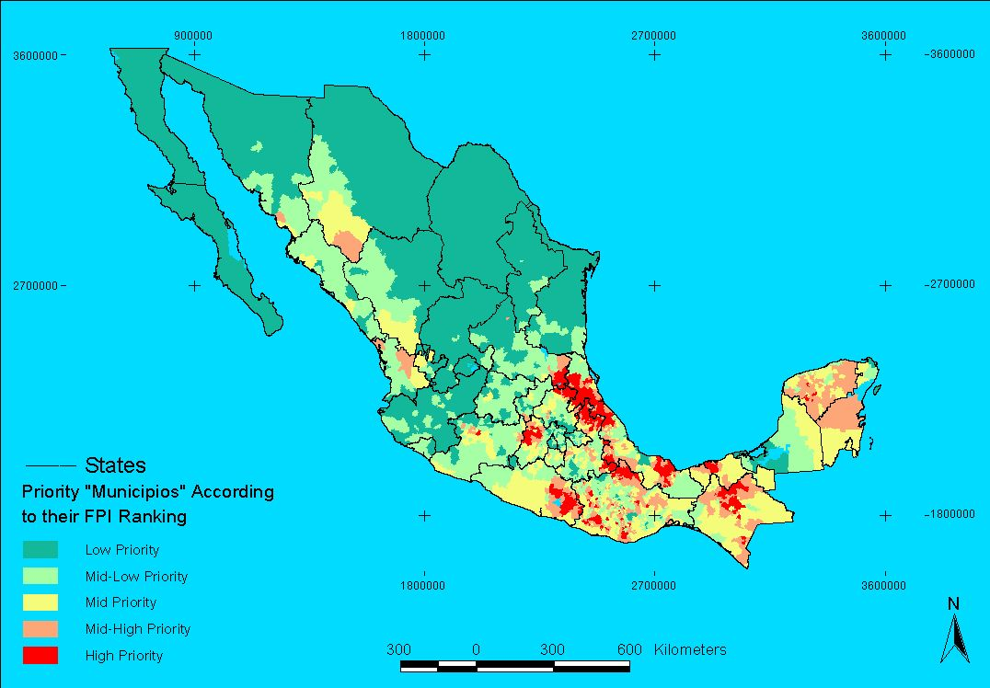
Figure 3 shows a detail of the central Mexican gulf region, comprising the “municipios” of Veracruz (left), Hidalgo (top right) and Puebla (bottom right). Extreme deforestation through the last three decades over this area has reduced considerably the supply of woodfuels, driving a major number of “municipios” to a critical situation. When reviewing the WISDOM database for Veracruz. We also see high growth rates of fuelwood users in critical “municipios”. Policy design at this scale should then consider these two variables as key factors in woodfuel scarcity over the entire region.

Figure 3. Priority “municipios” in terms of fuelwood use and availability of fuelwood resources, Mexico 2000. Detail for Central Gulf
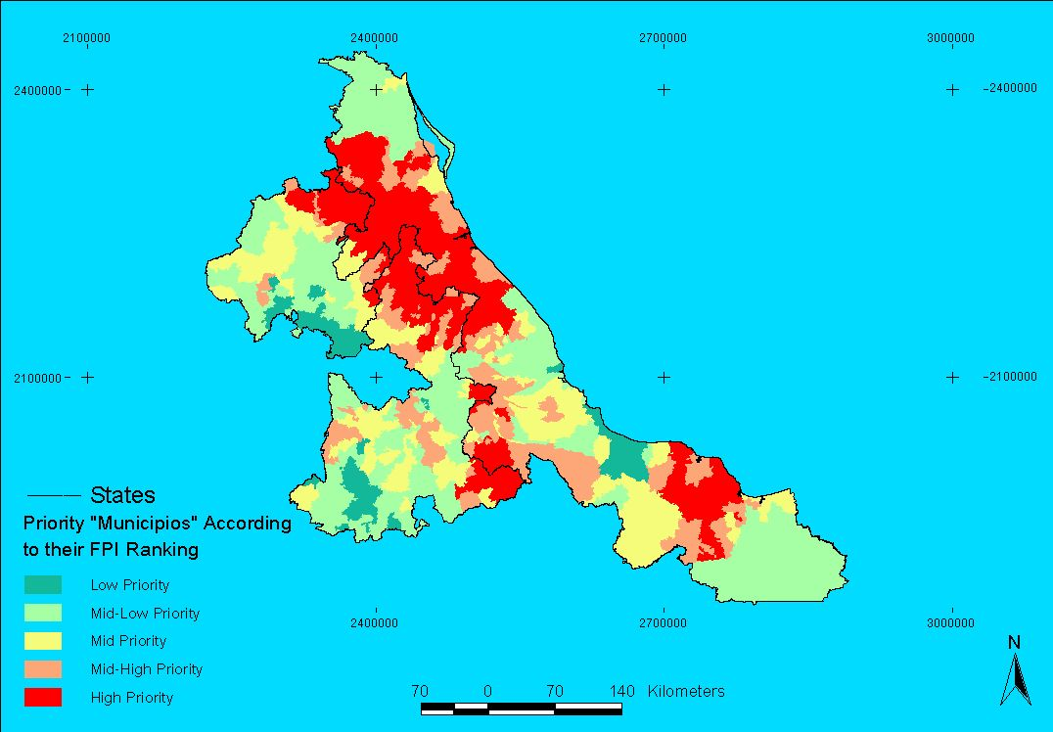

5. ADDRESSING PRIORITY AREAS AT THE LOCAL LEVEL: AN ACCESSIBILITY ANALYSIS

The WISDOM analysis carried out for Mexico allowed the identification of 262 high priority “municipios”, distributed over few aggregated areas. However, this should be just a first level of analysis. Accessibility studies may contribute to recognize priority areas at higher resolutions within the regions and “municipios” identified by WISDOM. Assessing the accessibility to fuelwood sources due to physical restrictions (i.e. slope, distance) and legal restrictions (i.e. protected areas) may allow helping to recognize those fuelwood sources areas more critical in terms of pressure by people’s demand. Accessibility studies not only restrict the fuelwood supply potential, but help quantify this pressure when considering the number of fuelwood users which can access limited portions of the whole forest area. In this section, we conduct an accessibility analysis over the “Purhépecha” Region of the State of Michoacan, using a GIS.

The following example attempts to: 1) estimate the potential forest areas accessible for fuelwood users of the “Purhépecha” Region, and 2) categorize those accessible forest areas, according to the pressure exerted by local people’s demand. The assumptions of the model are as follows:
- All of the human settlements censed by INEGI at year 2000 (isolated country households, small towns and villages) were incorporated as starting points for fuelwood gatherers.
- Displacement velocities through the terrain are a function of the slope and the geographic barriers only.
- Only walking fuelwood gatherers, with or without draft animals, were considered.
- All fuelwood gatherers walk 60 minutes or less (120 minutes for our second example), from their starting points and back.
- The different forest land covers were unified as one target area.

All human settlements were incorporated into a Geographic Information System (GIS) of the “Purhépecha” Region. The mean displacement velocities of walking fuelwood gatherers at different slopes were reestimated based on Puentes (2002) (Table 3). Corresponding velocities were used to create a “cost-distance” map, so called because movement through space can be considered to incur cost (in this case, because of increasing slopes; see table 3). Time buffers of 30 minutes and 60 minutes radius around each settlement were calculated using the cost-distance map. Buffers were then overlapped to a forest extent map of the “Purhépecha” Region. The resulting intersections were considered as those areas potentially accessible from settlements by walking fuelwood gatherers. The results shows that 40% of the total forest areas (121,000 ha) is accessible at 30 minutes. This value rises to 80% when considering 60 minutes buffers (242,000 ha) (table 5).

Table 4. Mean displacement velocities of fuelwood gatherers.
Slope | Displacement velocity (seconds spent per meter walked)
0º - 8.5º | 0.8
8.5º - 16.7º | 1.2
16.7º - 24.2º | 2.1
24.2º - 35º | 4.5
35º - 45º | 9
Source: Reestimated values from Puentes (2002).

Table 5. Accessible forest areas of the “Purhépecha” Region by walking fuelwood gatherers.
 | Area (ha) | Percentage
Total Forest Area of the “Purhépecha Region” | 301397 ha | 100%
Accessible forest areas at 30 minutes radius areas around each settlement. | 120867ha | 40%
Overlapped accessible forest area with four population densities
Less than 10 FW users per km² | 38,490 ha | 31,9% of 40%
10-25 FW users per km² | 34,984 ha | 28,9% of 40%
25-80 FW per km² | 30,710 ha | 25,4% of 40%
More than 80 FW users per km² | 15,984 ha | 13,2% of 40%
Accessible forest areas at 60 minutes radius areas around each settlement. | 241,757 ha | 80%
Overlapped accessible forest area with four population densities
Less than 10 FW users per km² | 113,706 ha | 47% of 80%
10-25 FW users per km² | 51,656 ha | 21,4% of 80%
25-80 FW per km² | 46,903 ha | 19,4% of 80%
More than 80 FW users per km² | 27,291ha | 11,3% of 80%

Figure 4 shows the potential forest areas (texturized surfaces) accessible for fuelwood extraction within the “Purhépecha” Region considering a 30 minute radius area around each settlement. Out of this range, under the model assumptions, the forest remains inaccessible for walking fuelwood gatherers (plain light gray).

For categorizing those accessible forest areas, according to the pressure exerted by local people’s demand the following method was followed. Circle areas of 3 Km radius around each settlement were selected. These areas were then divided by the number of fuelwood users in each corresponding locality so as to calculate their densities. A reclassification in four groups was made considering new calculated intersection densities (due to the overlapping of primary densities for all 3Km circles). Finally, this fourth density range map was overlapped to the accessible forest for identifying priority areas within the accessible forest. Figures 4 and 5 show the accessible forest areas for each density group (one texturize surface for each group). Dark areas represent the highest priority sites, considered by the model as prone to degradation because of the pressure (i.e. density) exerted by local fuelwood users. All dark areas sum almost 16,000 ha, corresponding to 13% of the total accessible forest of the region (table 5). This new priorization lays on the assumption that fuelwood demand is concentrated over more populous settlements and their close forest areas. It is important to remark that this kind of analysis only identifies priority areas with respect to an expected situation. Local surveys for quantifying forest harvesting on degradation as a cause from fuelwood extraction practices should be made in order to identify areas at risk from fuelwood shortages, based on site-specific information.

Figure 4. Accessible forest areas of the “Purhépecha” region at 30 minutes radius areas around each settlement.

Accessibility analyses, as any mathematical model, need continuum improvement. More sophisticated analyses may include the use of friction functions of velocity displacement according to land cover classes; fuelwood gatherers using motorized vehicles; registry land data; fuelwood market dynamics; small industrial woodfuel demand; woody biomass productivities by forest type; and biomass/woodfuel conversion factors. Most of the new assumptions must be made using local data from site-specific surveys. When considering these recommendations, accessibility analyses should be used as a needed link in a logical hierarchical approach, which goes from localizing priority “municipios” at a national level, to selecting community forest areas where action is needed.

Figure 5. Accessible forest areas of “Nahuatzen”, in the “Purhépecha” region at 30 minutes radius areas around each settlement.
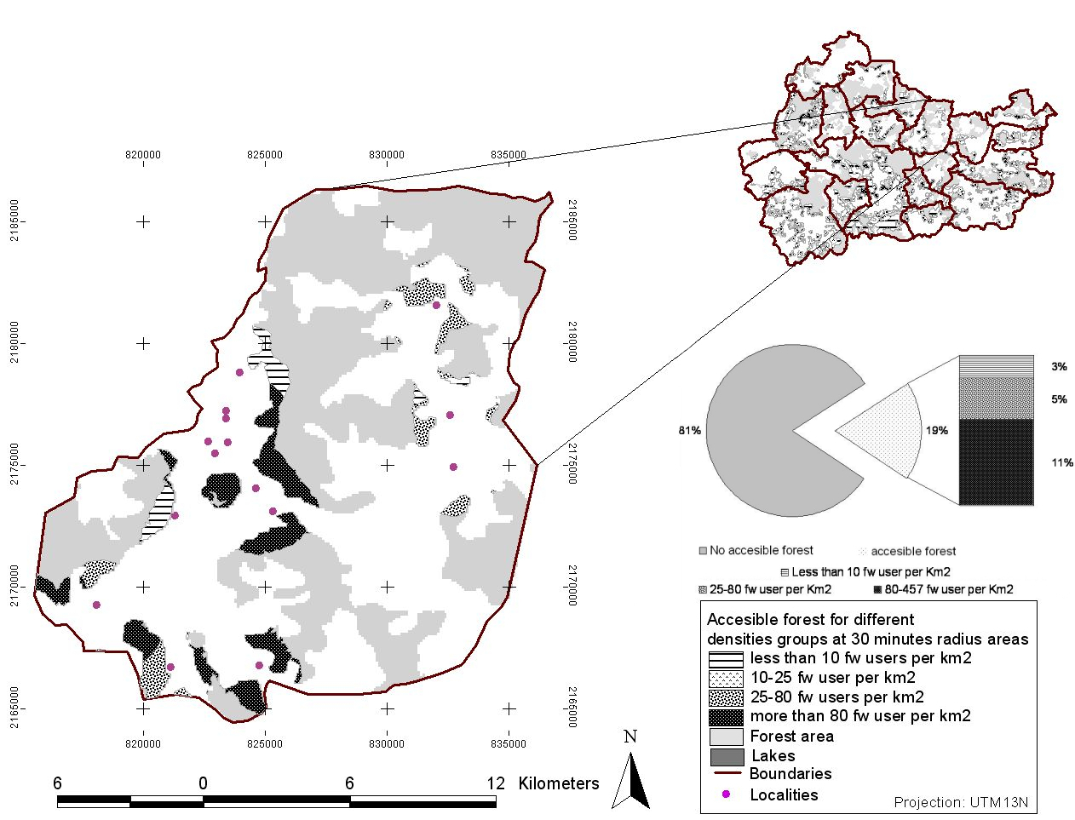

6. CONCLUSIONS

Most developing countries with high rates of woodfuel consumption also lack the financial resources needed for the design and implementation of appropriate policies to combat woodfuels scarcity and its associated environmental impacts (e.g. deforestation). Multiscale assessments of woodfuel priority areas appear as an attractive option for concentrating government resources to critical areas. Risk zones are those were action should be taken. National policy planning should be carried out considering those critical areas identified at the broadest scale (Figures 1 and 2). Practical implementation of policies should then be taken considering the specific areas identified at the minimum level of analysis. In other words, we need to go from planning to action following the emergent properties and characteristics that appears for each successive scale of analysis.

Considering the Mexican example: a national priorization using WISDOM allowed the identification of 262 “municipios” out of 2402, leading to a reduction of target areas of almost 90%. Following the hierarchical framework stated above, an accessibility analysis was conducted over the “Purhepecha” region. This region is conformed by a group of “municipios” classified by WISDOM as mid, mid-high and high priority. This new priorization allowed the identification of those forest areas, within critical “municipios”, under pressure because of their accessibility by fuelwood gatherers.

Woodfuels multiscale assessment helps in identifying areas where intervention is most needed, optimizing those government resources designated for the sector. This is a contribution to the sustainable use of woodfuel resources as increases the feasibility of implementation of national plans.
7. REFERENCES

Del Amo S. (coord.), 2002. La leña: el energético rural en tres micro-regiones del sureste de México. Programa de Acción Forestal Tropical (PROAFT A.C.). Plaza y Valdéz Editores, México D.F.

De Montalembert M. R. & J. Clement, 1983. “Fuelwood Supplies in the Developing Countries”. Forestry Paper N°42. Food and Agriculture Organization of the United Nations, Rome.

Díaz R., 2000. “Consumo de leña en el sector residencial de México: evolución histórica y emisiones de CO2”. National University of Mexico (UNAM). Master Thesis, Mexico City.

ESMAP, 2001. “Sustainable Woodfuel Supplies from the Dry Tropical Woodlands”. Energy Sector Management Assistance Programme and United Nations Development Programme. The World Bank, Washington D.C.

Mahapatra A.K. & C.P. Mitchell, 1999. “Biofuel consumption, deforestation, and farm level tree growing in rural India”. Biomass and Bioenergy 17:291-303.

Masera O.R., 1993. "Sustainable Fuelwood Use in Rural Mexico, Volume I: Current Patterns of Resource Use", Report #LBL-34634, Energy and Environment Division, Lawrence Berkeley Laboratory. University of California, Berkeley, California. (Not Cited)

Masera O., J. Navia, T. Arias, E. Riegelhaupt, 1997. “Patrones de Consumo de Leña en Tres Micro-regiones de México: Síntesis de Resultados”. Proyecto FAO/MEX/TCP/4553(A). Grupo Intrediciplinario de Tecnología Rural Apropiada (GIRA A.C.). Pátzcuaro, México.

Masera O., D. Masera, J. Navia, 1998. “Dinámica de uso de los recursos forestales de la Región Purhépecha: El papel de las pequeñas empresas artesanales”. Grupo Intrediciplinario de Tecnología Rural Apropiada (GIRA A.C.). Pátzcuaro, México.

Masera O., R. Drigo, M.A. Trossero, 2003a. “Woodfuels Integrated Supply/Demand Overview Mapping (WISDOM): A methodological approach for assessing woodfuel sustainability and support wood energy planning”. FAO Reports, Wood Energy Programme, Forest Products Division. Food and Agriculture Organization of the United Nations, Rome.

Masera O., G. Guerrero, A. Ghilardi, A. Velázquez, J.F. Mas, M. Ordóñez, R. Drigo, 2003b. “Identifying household fuelwood Hot Spots using the WISDOM approach: a case study for México. Wood Energy Programme, Forest Products Division. Food and Agriculture Organization of the United Nations, Rome. (In press).

Newcombe K., 1984. “An Economic Justification for Rural Afforestation: The Case of Ethiopia”. Energy Department Paper N°16. World Bank, Washington, D.C.
RWEDP, 1997. “Regional study on wood energy today and tomorrow in Asia”. Regional Wood Energy Development Programme in Asia GCP/RAS/154/NET. Field Document N°50. Food and Agriculture Organization of the United Nations / Kingdom of The Netherlands. Bangkok, Thailand.
RWEDP, 2000. “Basics of Wood Energy Planing - A Manual -”. Regional Wood Energy Development Programme in Asia GCP/RAS/154/NET. Food and Agriculture Organization of the United Nations / Kingdom of The Netherlands. Bangkok, Thailand.
Secretaría de Energía (SENER), 2001. “Balance Nacional de Energía”. Gobierno de México, Secretaría de Energía, México D.F.

LAMNET Project Coordination
LAMNET Coordination Support Point
South America

CENBIO – Centro National de Referência em Biomassa
Avenida Prof. Luciano Gualberto 1289
05508-900 São Paulo
Brazil
Contact: Prof. Dr. José Roberto Moreira
Phone: +55 115 531 1844
Fax: +55 115 535 3077
E-mail: Bun2@tsp.com.br
Web: www.cenbio.org.br

LAMNET Coordination Support Point
Central America

Universidad Nacional Autónoma de México Instituto de Ecología
AP 27-3 Xangari
58089 Morelia, Michoacán, México
Contact: Dr. Omar Masera
Phone: +52 55 5623 2709
Fax: +52 55 5623 2719
E-mail: omasera@oikos.unam.mx
Web: www.oikos.unam.mx

Steering Committee
Contact: Dr. Peter Helm
E-mail: peter.helm@wip-munich.de

WIP
Sylvensteinstr. 2
81369 Munich
Germany
Coordinator: Dr. Rainer Janssen
Phone: +49 89 720 12 743
Fax: +49 89 720 12 791
E-mail: rainer.janssen@wip-munich.de
Web: www.wip-munich.de

LAMNET Coordination Partner

ETA – Energia Trasporti Agricoltura
Piazza Savonarola, 10
50132 Florence
Italy
Contact: Ms. Angela Grassi
Phone: +39 055 500 2174
Fax: +39 055 573 425
E-mail: angela.grassi@etaflorence.it
Web: www.etaflorence.it

LAMNET Coordination Partner

EUBIA – European Biomass Industry Association
Rond Point Schuman, 6
1040 Brussels
Belgium
Contact: Dr. Giuliano Grassi
Phone: +32 2 28 28 420
Fax: +32 2 28 28 424
E-mail: eubia@eubia.org
Web: www.eubia.org






This Thematic Network is funded by the European Commission, DG Research,
(Project No. ICA4-CT-2001-10106).

